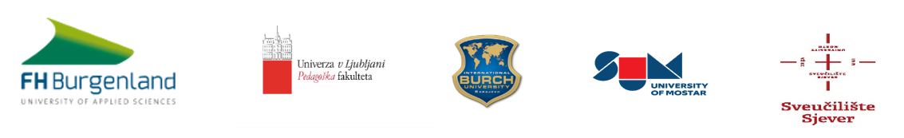
Application Form
for the academic year 2020/2021

International Cooperative Cross-Border Interdisciplinary Doctoral Programme in

Educational & Communication Sciences

Personal data

<<Photograph>
Surname
First name, middle name (if applicable, please limit to a max of two middle names)

Sex
male female

Birthday DDMMYYYY

Citizenship Native Language

Address
Country Postal Code City
-
Province
Telephone
E-mail

I hereby apply for admission to the

International Cooperative Cross-Border Interdisciplinary Doctoral Programme
in Educational & Communication Sciences

in Eisenstadt for the academic year 2020/2021.

Date Signature

I. Short Curriculum Vitae et Studiorum
(you may add this as separate attachment)

What else should we know in detail?
Please attach copies of all available certificates to this application.

II. EDUCATION
University/Higher education history

 |  |  | Duration
Name of institution | Course of study | Diploma(s) earned  (degree/certificates) | from | to

III. Professional experience and current professional situation:

Company, employer*  (incl. address) | Short description of activity | since (month/year) | hours**

What else should we know about you?

* Please indicate the country.
** If no confirmation letter of an employer is available, add copies of other proof
IV. Additional qualifications

- Education History (e.g. courses, seminars, continued education etc.)

 |  | Certificate | Duration |  | Hours (approx.)
Course - Topic | Institution |  | from | to

2. Languages
(studied at school, in language courses, native competence etc.)

Language | Studied at |  | Level | Certificates  available, please check |  | Time* |  | Hours* (approx.)
 | Institution | Country |  | Yes | No | From | to
very good marginal
1 - 2 - 3 - 4 - 5 - 6
(Check the selection that applies)

very good marginal
1 - 2 - 3 - 4 - 5 - 6
(Check the selection that applies)

very good marginal
1 - 2 - 3 - 4 - 5 - 6
(Check the selection that applies)

very good marginal
1 - 2 - 3 - 4 - 5 - 6
(Check the selection that applies)

Also indicate certificates you hold such as e.g. BEC 1 (Cambridge Business English Certificate), CPE (Certificate of Proficiency in English), CAE (Certificate in Advanced English) or any other language certificates you may have earned.

* e.g. French - 9/20014 - 5/2015 – throughout high school - 3 hrs/week or English - 3 week language course - Ireland
Attach any certificates that may apply.
V. Time spent abroad
(Au-pair, job, semester abroad, language courses... Vacations are not relevant)

 |  | Proof available |  | Duration
Country | Purpose of stay, short description | yes | no | from  month | year | to month | year

Please attach copies of your documents and confirmations.

VI. Statement of personal intent
(Motivation letter)

Why do you wish to study within the International Cooperative Cross-Border PhD Programme?
(you may add this statement as separate attachment)

VII. Recommendation letter(s)
(if available)

VIII. Research Proposal – your orientation and the planned research field (idea/ brief
synopsis) with a (possible) List of Publications

A research proposal has to include (at least) the following information:

- Working title of the dissertation
- description of the topic of the doctoral thesis including a clear research question/research questions,
- outline of the state of research , literature-based, already existing research in your research field
- illustration of the chosen research methods (qualitative/quantitative)
- possible outcomes (hypothesis/hypotheses)
- relevant literature
- time and work schedule

